**1.1**

1. Display unique Jobs from EMP table

Solution:

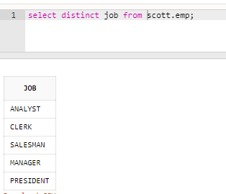

2. List the employees in the ascending order of their salaries

Solution:

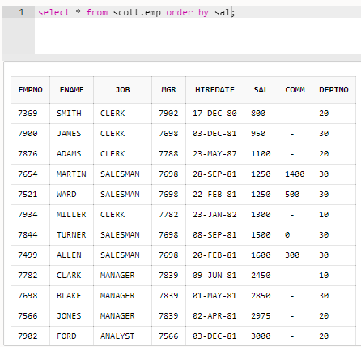

3. List the details of the employees in ascending order of the dept no and descending of Jobs

Solution:

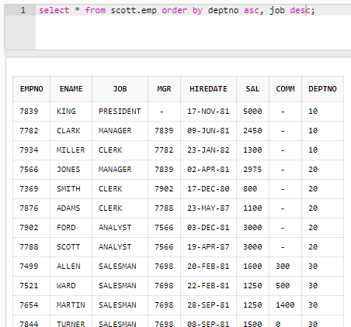

4. Display all the unique job groups in the descending order

Solution:

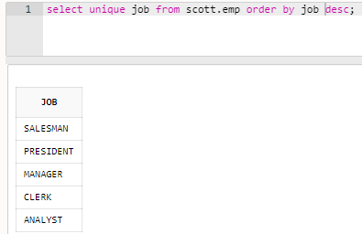

5. Display all the employees who are managers

Solution:

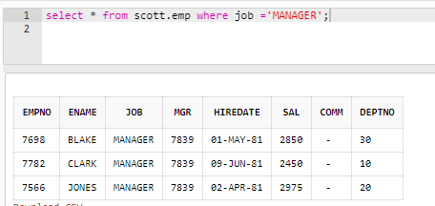

6. List the employees who joined before 1981

Solution:

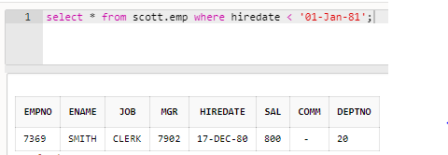

7. List the Empno, Ename, Sal, daily sal of all employees in the ascending order of annual sal

Solution:

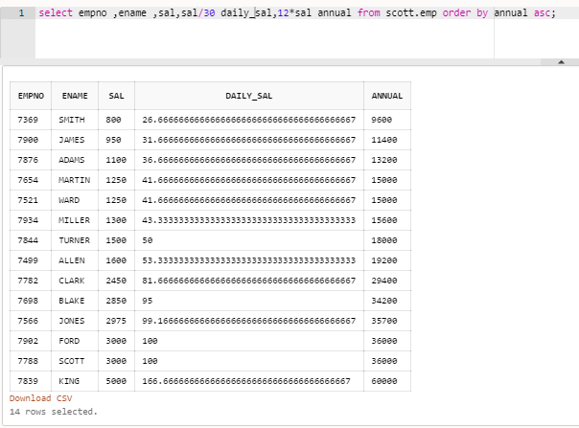

8. Display the Empno, Ename, job, Hiredate, Exp of all Mgrs

Solution:

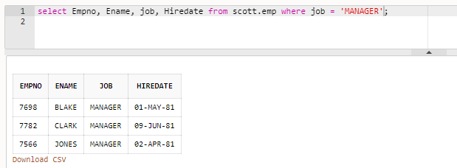

9. List the Empno, Ename, Sal, experience of all employees working for Mgr=7369

Solution:

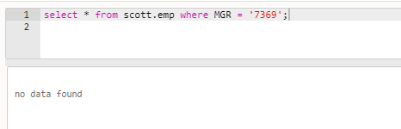

10. Display all the details of the employees whose Comm. Is more than their Sal

Solution:

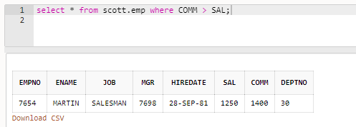

11. List the employees in the asc order of Designations of those joined after the second half of 1981

Solution:

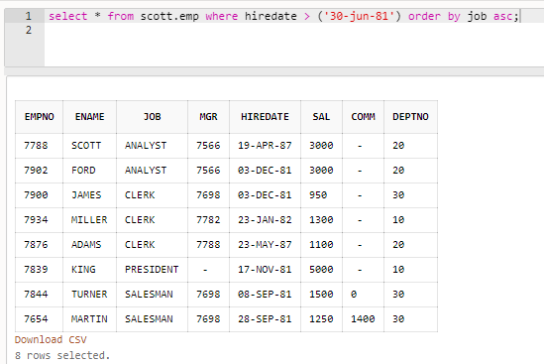

12. List the employees along with their experience and daily salary is more than Rs.100

Solution:

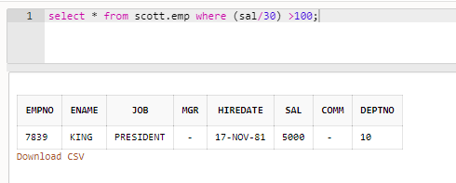

13. List the employees who are either ‘CLERK’ or ‘ANALYST’ in the Desc order

Solution:

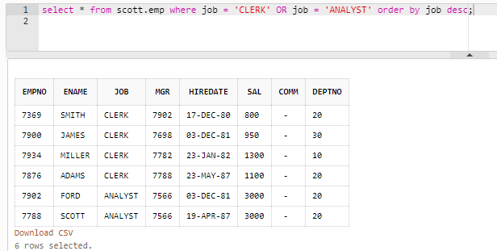

14. List the employees who joined on 1-MAY-81,3-DEC-81,17-DEC-81,19-JAN-80 in asc order of seniority

Solution:

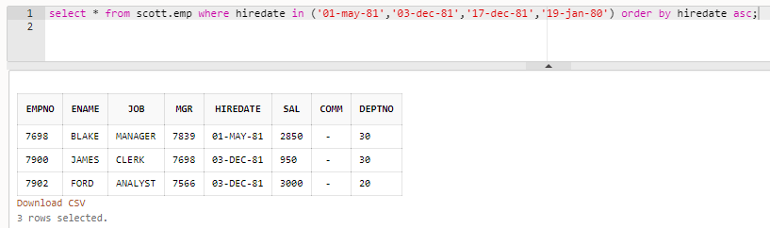

15. List the emp who are working for the Deptno 10 or 20

Solution:

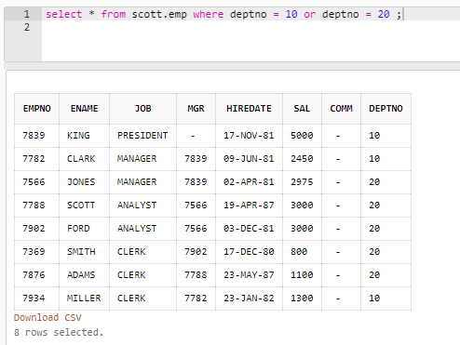

16. List the employees who are joined in the year ‘81

Solution:

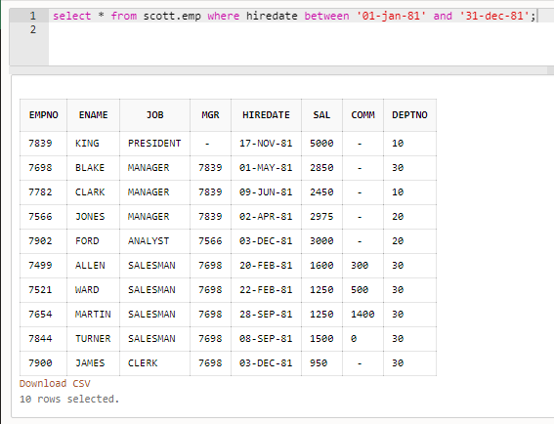

17. List the employees who are joined in the month of Aug 1980

Solution:

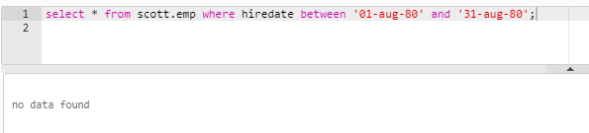

18. List the Enames those are having five characters in their Names

Solution:

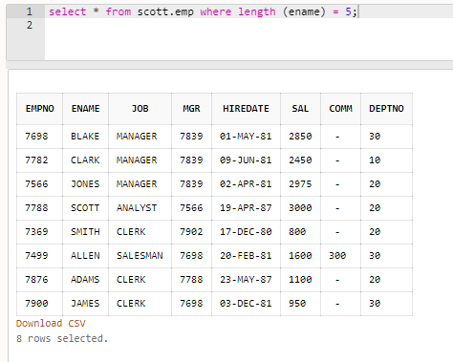

19. List the Enames those are starting with ‘S’ and with five characters

Solution:

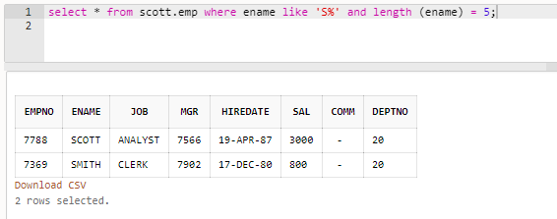

20. List the employees those are having four chars and third character must be ‘r’

Solution:

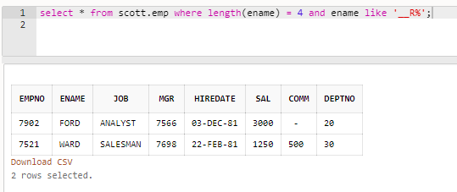

21. List the names of those employees whose employee numbers are 7369, 7521, 7839, 7934, 7788.

Solution:

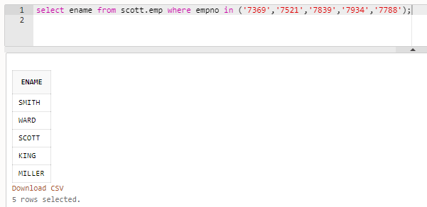

22. List those employees who do not belonging to department 30, 40, or 10.

Solution:

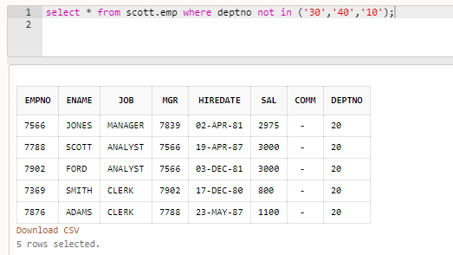

23. List those employee names who have joined between 30 June and 31 Dec ‘81.

Solution:

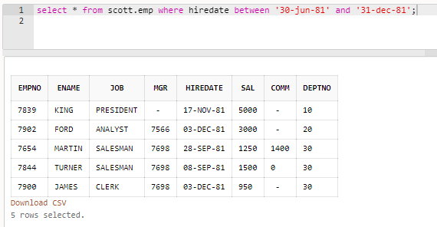

24. List the different designations available in the company

Solution:

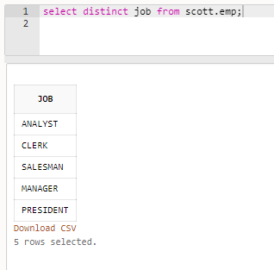

25. List those employees name that are not eligible for commission

Solution:

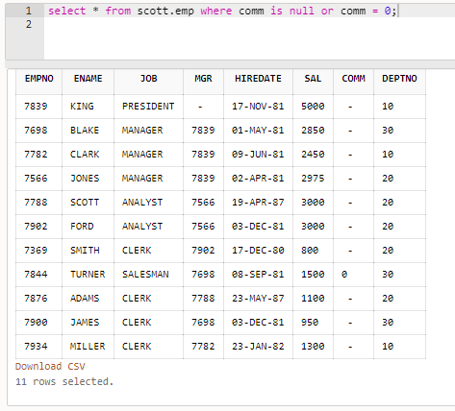

26. List the name of the employee and designation of the employee who does not report to anybody

Solution:

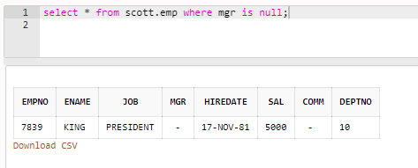

27. List the employees who are eligible for commission

Solution:

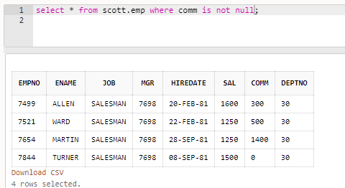

28. List names of employees if the names have “i” as the second character

Solution:

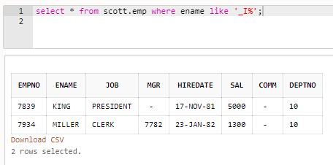

29. Display the names of all employees with their salary and commission earned. Employees with a null commission field should have 0 in the commission column

Solution:

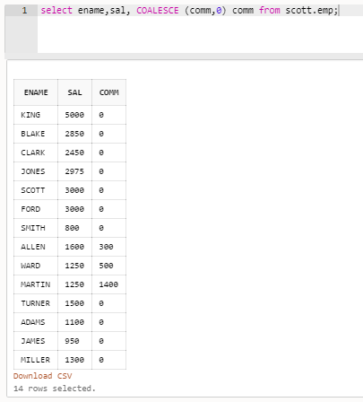

**1.2**

1. List the count and average salary for employees in department 20.

Solution:

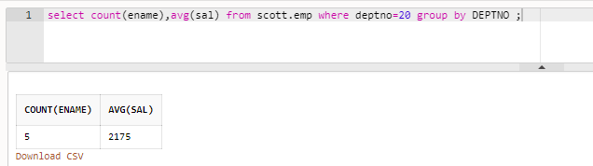

2. List names of employees who are older than 30 years in the company.

Solution:

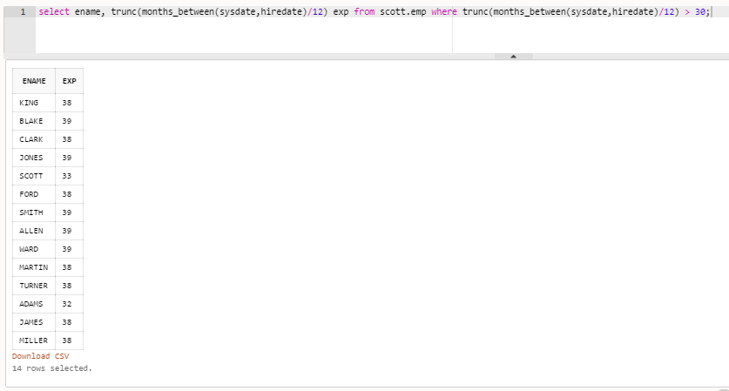

3. List the employee name , hire date in the descending order of the hire date.

Solution:

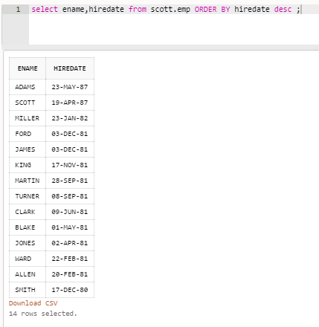

4. List employee name, salary, PF, HRA, DA and gross; order the results in the ascending order of gross. HRA is 50% of the salary and DA is 30% of the salary.

Solution:

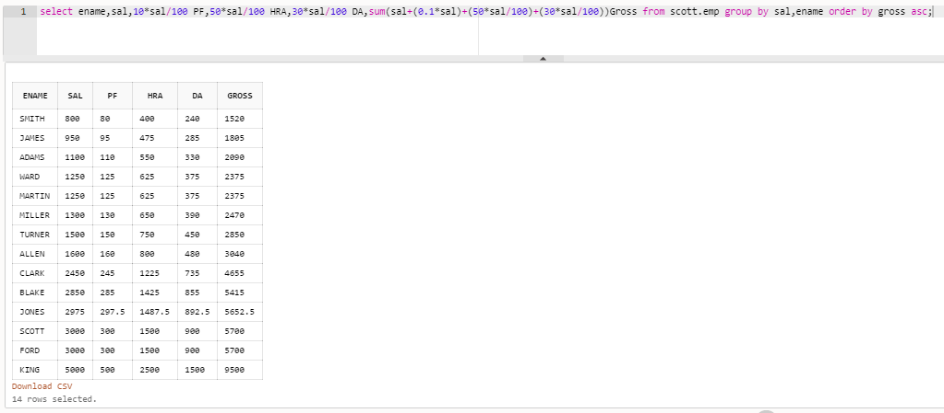

5. List the department numbers and number of employees in each department.

Solution:

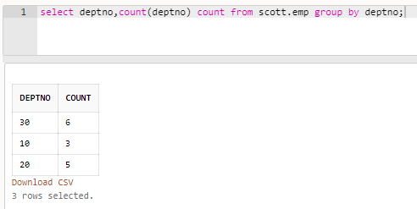

**1.3**

1. List employees whose job is same as that of Smith

Solution:

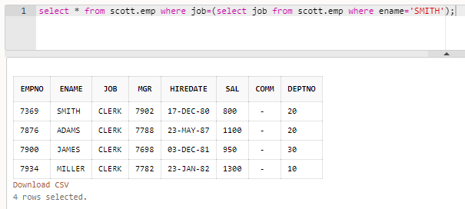

2. List employees who have joined after Adam

Solution:

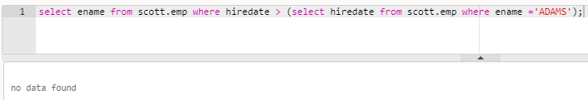

3. List employees who salary us greater than Scott’s salary

Solution:

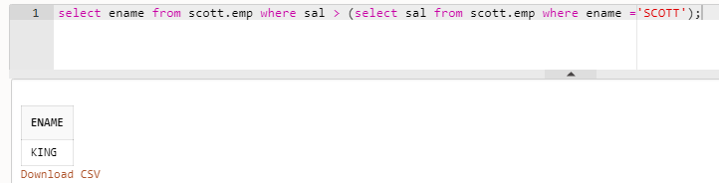

4. List employees getting the max salary.

Solution:

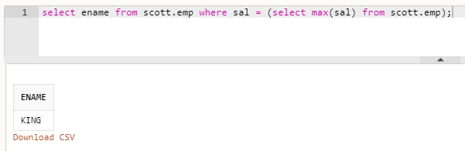

5. List employees show salary is > the max salary in deptno 30.

Solution:

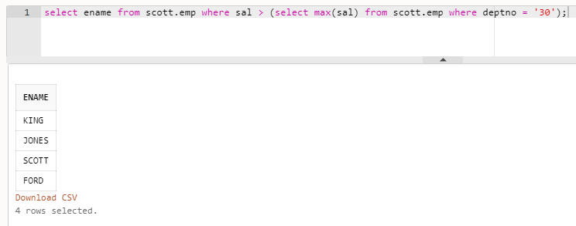

**1.4**

1. List employee name, department number and their corresponding department name.

Solution:

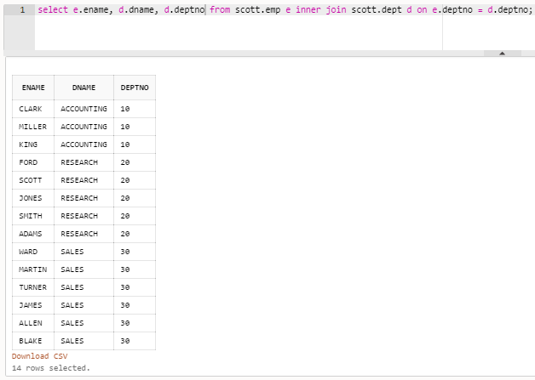

2. List employee name and their manager name

Solution:

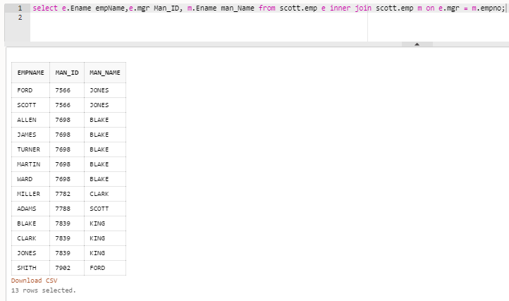

3. List employees who work in Research department

Solution:

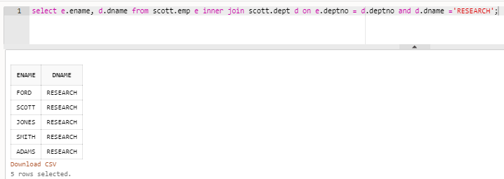

4. List all rows from EMP table and only the matching rows from DEPT table.

Solution:

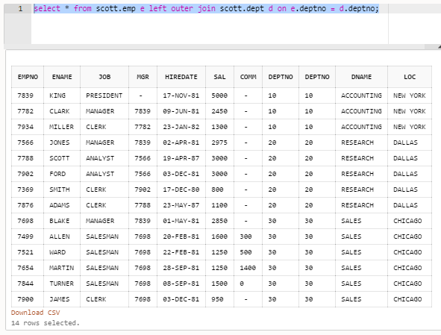

5. List all rows from EMP table and only the matching rows from DEPT table.

Solution:

